#include <iostream>

#include <time.h>

#include <iomanip>

using namespace std;

const int k = 4;

const int m = 4;

/*

//1

void Get(int x[][k], int N) {

for (int i = 0; i < N; i++)

for (int j = 0; j < N; j++)

cin >> x[i][j];

}

void Out(int x[][k], int N) {

for (int i = 0; i < k; i++) {

for (int j = 0; j < k; j++) {

cout << setw(5) << x[i][j];

}

cout << "\n";

}

}

int main()

{

setlocale(LC_ALL, "Russian");

int A[m][k];

Get(A, m);

Out(A, m);

}

*/

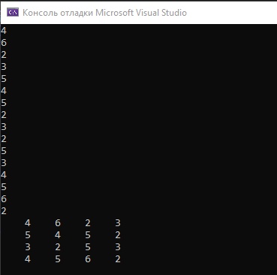

/*

//2

void Get(int x[][k], int N) {

for (int j = 0; j < N; j++)

for (int i = 0; i < N; i++)

cin >> x[i][j];

}

void Out(int x[][k], int N) {

for (int j = 0; j < k; j++) {

for (int i = 0; i < k; i++) {

cout << setw(5) << x[i][j];

}

cout << "\n";

}

}

int main()

{

setlocale(LC_ALL, "Russian");

int A[m][k];

Get(A, m);

Out(A, m);

}

*/

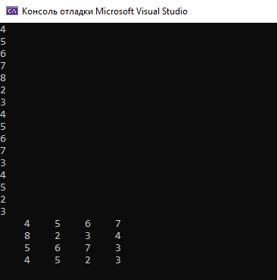

/*

//3

void Get(int x[][k], int N) {

for (int j = 0; j < N; j++)

for (int i = 0; i < N; i++)

cin >> x[i][j];

}

void Out(int x[][k], int N) {

for (int j = 0; j < k; j++) {

for (int i = 0; i < k; i++) {

cout << setw(5) << x[i][j];

}

cout << "\n";

}

}

void Ran(int X[][k], int N, int a, int b) {

for (int i = 0; i < N; i++)

for (int j = 0; j < k; j++)

X[i][j] = a + rand() / 7;

}

int main()

{

setlocale(LC_ALL, "Russian");

int A[m][k];

int B[5][k];

Ran(B, 5, -10, 10);

cout << "\n" << " Таблица " << "\n";

Out(B, 5);

Get(A, m);

Out(A, m);

}

*/

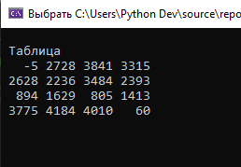

/*

//4

void Get(int x[][k], int N) {

for (int j = 0; j < N; j++)

for (int i = 0; i < N; i++)

cin >> x[i][j];

}

void Out(int x[][k], int N) {

for (int j = 0; j < k; j++) {

for (int i = 0; i < k; i++) {

cout << setw(5) << x[i][j];

}

cout << "\n";

}

}

void Out2(int x[][k], int N) {

for (int i = 0; i < k; i++) {

for (int j = 0; j < k; j++) {

cout << setw(5) << x[i][j];

}

cout << "\n";

}

}

void Ran(int x[][k], int N, int a, int b) {

for (int i = 0; i < N; i++)

for (int j = 0; j < k; j++)

x[i][j] = a + rand() / 7;

}

int main()

{

setlocale(LC_ALL, "Russian");

int B[5][k];

Ran(B, 5, -10, 10);

cout << "\n" << "||||||||||||||||||||||||||||" << "\n"; Out(B, 5);

cout << "\n" << "||||||||||||||||||||||||||||" << "\n"; Out2(B, 5);

}

*/

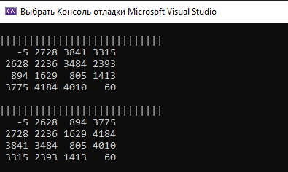

/*

// 1

void Get(int x[][k], int N) {

for (int i = 0; i < N; i++)

for (int j = 0; j < N; j++)

cin >> x[i][j];

}

void Out(int x[][k], int N) {

for (int i = 0; i < k; i++) {

for (int j = 0; j < k; j++) {cout << setw(5) << x[i][j];}

cout << "\n";

}

}

void Out2(int x[][k], int N) {

for (int i = 0; i < k; i++) {

for (int j = 0; j < k; j++) {cout << setw(5) << x[i][j];}

cout << "\n";

}

}

void Ran(int x[][k], int N, int a, int b) {

for (int i = 0; i < N; i++)

for (int j = 0; j < k; j++)

x[i][j] = a + rand() / 7;

}

int main()

{

setlocale(LC_ALL, "Russian");

srand(time(NULL));

int B[5][k];

int S = 0;

Ran(B, 5, -10, 10);

cout << "\n" << "||||||||||||||||||||||||||||" << "\n"; Out(B, 5);

for (int i = 0; i < 5; i++)

for (int j = 0; j < k; j++)

S += B[i][j];

cout << " S = " << S << "\n";

}

*/

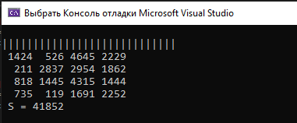

/*

// 2

void Get(int x[][k], int N) {

for (int i = 0; i < N; i++)

for (int j = 0; j < N; j++)

cin >> x[i][j];

}

void Out(int x[][k], int N) {

for (int i = 0; i < k; i++) {

for (int j = 0; j < k; j++) {

cout << setw(5) << x[i][j];

}

cout << "\n";

}

}

void Ran(int x[][k], int N, int a, int b) {

for (int i = 0; i < N; i++)

for (int j = 0; j < k; j++)

x[i][j] = a + rand() / 7;

}

int main()

{

srand(time(NULL));

setlocale(LC_ALL, "Russian");

int B[5][k];

Ran(B, 5, -10, 10);

cout << "\n" << " ||||||||||||||||||| " << "\n"; Out(B, 5);

int P = 1;

for (int i = 0; i < k; i++)

for (int j = 0; j < k; j++)

P *= B[i][j];

cout << " P = " << P << "\n";

}

*/

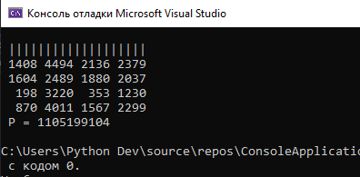

/*

// 3

void Get(int x[][k], int N) {

for (int i = 0; i < N; i++)

for (int j = 0; j < N; j++)

cin >> x[i][j];

}

void Out(int x[][k], int N) {

for (int i = 0; i < k; i++) {

for (int j = 0; j < k; j++) {

cout << setw(5) << x[i][j];

}

cout << "\n";

}

}

void Ran(int x[][k], int N, int a, int b) {

for (int i = 0; i < N; i++)

for (int j = 0; j < k; j++)

x[i][j] = a + rand() / 7;

}

int main()

{

srand(time(NULL));

setlocale(LC_ALL, "Russian");

int B[5][k];

int count = 0;

Ran(B, 5, -10, 10);

cout << "\n" << " |||||||||||||| " << "\n"; Out(B, 5);

for (int i = 0; i < k; i++)

for (int j = 0; j < k; j++)

if (B[i][j] > 0)

count++;

cout << " count = " << count << "\n";

}

*/

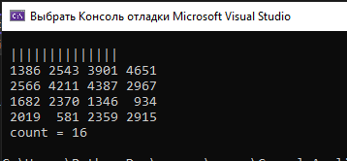

/*

// 4

void Get(int x[][k], int N) {

for (int i = 0; i < N; i++)

for (int j = 0; j < N; j++)

cin >> x[i][j];

}

void Out(int x[][k], int N) {

for (int i = 0; i < k; i++) {

for (int j = 0; j < k; j++) {

cout << setw(5) << x[i][j];

}

cout << "\n";

}

}

void Ran(int x[][k], int N, int a, int b) {

for (int i = 0; i < N; i++)

for (int j = 0; j < k; j++)

x[i][j] = a + rand() / 7;

}

int main()

{

srand(time(NULL));

setlocale(LC_ALL, "Russian");

int B[5][k];

int S = 0;

Ran(B, 5, -10, 10);

cout << "\n" << " |||||||||||||| " << "\n"; Out(B, 5);

for (int i = 0; i < k; i++)

S += B[i][i];

cout << " S = " << S << "\n";

}

*/

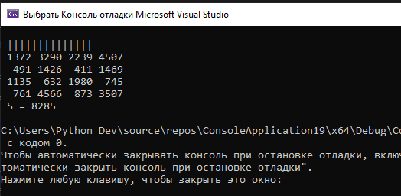

/*

// 5

void Out(int x[][k], int N) {

for (int i = 0; i < k; i++) {

for (int j = 0; j < k; j++) {

cout << setw(5) << x[i][j];

}

cout << "\n";

}

}

void Ran(int x[][k], int N, int a, int b) {

for (int i = 0; i < N; i++)

for (int j = 0; j < k; j++)

x[i][j] = a + rand() / 7;

}

int main()

{

srand(time(NULL));

setlocale(LC_ALL, "Russian");

int B[4][k];

int S = 1;

int s;

Ran(B, 4, -10, 10);

cout << "\n" << " |||||||||||||| " << "\n";

Out(B, 4);

cout << "Введите индекс ";

cin >> s;

for (int i = 0; i < 4; i++) {

if (B[i][s] % 2 != 0) {

S *= B[i][s];

}

}

cout << " S = " << S << "\n";

}

*/

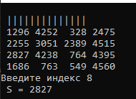

#include <iostream>

#include <iomanip>

#include <fstream>

#include <iostream>

using namespace std;

int main(int argc, char* argv[])

{

// 1-условно "стенки лабиринта"

// 2-"правильный путь, выход из лабиринта"

// 0-"ложный путь"

// инициализаци¤ двумерного массива

int mas[33][20] = {

{1,1,2,1,1,1,1,1,1,1,1,1,1,1,1,1,1,1,1,1,},

{1,1,2,0,0,0,0,0,0,0,0,0,0,1,0,1,0,1,0,1,},

{1,1,2,1,1,1,1,1,1,1,1,1,0,1,0,1,0,1,0,1,},

{1,1,2,1,1,1,1,1,1,1,1,1,0,1,0,1,0,1,0,1,},

{1,1,2,0,0,0,0,0,0,0,0,0,0,0,0,0,0,0,0,1,},

{1,1,2,1,1,1,1,1,1,1,1,1,1,1,1,1,1,1,0,1,},

{1,1,2,1,1,1,1,1,1,1,0,1,1,1,0,0,0,1,0,1,},

{1,1,2,0,0,0,0,0,0,1,0,0,0,0,0,1,1,1,0,1,},

{1,1,2,1,1,1,1,1,0,1,1,1,1,1,0,0,1,1,0,1,},

{1,1,2,1,1,1,0,1,0,0,0,0,0,0,0,0,0,1,0,1,},

{1,1,2,1,0,1,0,1,1,1,1,1,1,1,1,1,1,1,0,1,},

{1,1,2,1,0,1,0,1,0,0,0,0,0,0,0,0,0,0,0,1,},

{1,1,2,1,0,1,0,1,0,1,1,1,1,1,1,1,1,1,1,1,},

{1,1,2,0,0,0,0,0,0,0,0,0,0,0,0,0,0,0,0,1,},

{1,1,2,1,1,0,1,1,1,1,1,1,1,1,1,1,0,1,1,1,},

{1,1,2,1,1,0,1,0,0,0,0,0,0,0,0,0,0,0,0,1,},

{1,1,2,1,1,0,1,1,1,1,1,1,1,1,1,1,0,1,0,1,},

{1,1,2,1,1,0,1,1,1,1,1,1,0,1,0,1,0,0,1,1,},

{1,1,2,1,1,0,1,0,1,0,0,1,0,0,0,1,0,0,0,1,},

{1,1,2,1,1,0,1,0,0,0,0,0,0,0,0,0,0,0,0,1,},

{1,1,2,1,1,0,1,1,1,1,1,1,1,1,1,1,1,1,1,1,},

{1,1,2,1,1,0,0,0,0,0,0,0,0,0,0,0,0,0,0,1,},

{1,1,2,1,1,1,1,1,1,1,1,1,1,1,1,1,1,1,0,1,},

{1,1,2,0,0,1,0,0,0,0,0,0,0,0,0,1,0,1,0,1,},

{1,1,2,1,0,1,0,0,1,1,1,1,1,1,0,1,0,1,0,1,},

{1,1,2,1,1,1,0,0,1,0,0,0,0,1,0,1,0,1,0,1,},

{1,1,2,0,0,0,0,1,1,0,1,1,1,1,0,1,1,1,0,1,},

{1,1,2,1,1,0,0,0,0,0,0,0,0,0,0,0,0,0,0,1,},

{1,1,2,1,1,0,1,1,1,1,1,1,1,1,1,1,1,0,1,1,},

{1,1,2,1,1,0,0,0,0,0,0,0,0,0,0,0,0,0,0,1,},

{1,1,2,1,1,1,1,1,1,1,1,1,1,1,1,1,1,1,1,1,},

{1,1,2,2,2,2,2,2,2,2,2,2,2,2,2,2,2,2,2,2,},

{1,1,1,1,1,1,1,1,1,1,1,1,1,1,1,1,1,1,1,1,} };

// два цикла - внутренний и внешний, осуществл¤ющие обращение к каждому элементу массива

for (int i = 0; i < 33; i++) //обход по строкам

{

for (int j = 0; j < 20; j++)// обход по столбцам

if (mas[i][j] == 1)

{

// вывести два раза символ (номер которого 176 в таблице ASCII) в консоль

cout << static_cast<char>(176);

//cout << static_cast<char>(176);

}

else

cout << " "; // вывести два пробела

cout << "\n";

}

system("pause");

return 0;

}

